October SEL Newsletter
October’s SEL Skill is Stress Management:
How to Become a Manager of Stress:
What is Stress?
- Stress is a feeling that's created when we react to particular events.
- It's the body's way of rising to a challenge and preparing to meet a tough situation with focus, strength, stamina, and heightened alertness.
- The events that provoke stress are called Stressors.
- Taking a test | - Having an argument with your friend
- A class presentation | - Parents’ expectations
- Talking to a cute boy at lunch | - What are some other stressors in your life?

Our Body Tells Us When We are Stressed:
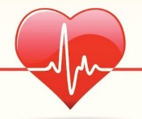
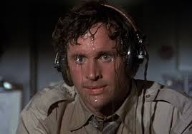
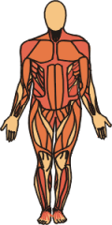
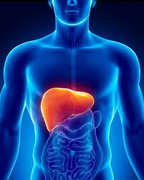
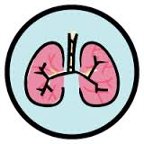
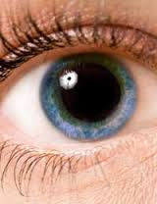
Body Cues = Physical changes that prepare a person to react quickly and effectively to handle the pressure of the moment
Increased heart rate
Sweat is produced to cool the body
Blood vessels open wider to let more blood flow to large muscle groups
Liver releases glucose to increase the body's energy
Increased breathing rate
Pupils dilate to improve vision

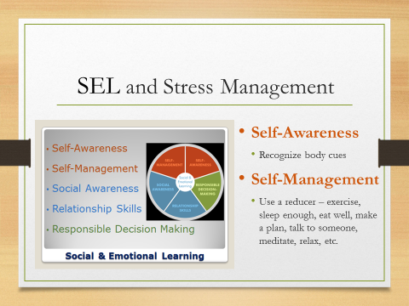

De-Stressifying: Ways to Reduce Stress

De-stressifying Tips | Tip #1 | Tip #2
- Treat your body well | - Regular exercise helps people manage stress. | - Eat well to help your body get the right fuel to function at its best.
- Make a plan | - Ask yourself, “What is out of my control? What can I control?” | - Then make a plan and take action toward a solution.
- Get a good night's sleep | - You need 8.5-9.5 hours per night!! | - Turn off all electronics 1 hour before bedtime
- Reach out | - When you’re stressed your body releases the hormone OXYTOCIN. | - TALK to your mom, dad, sister, brother, friend, teacher, neighbor, aunt, uncle, teacher, cousin, teammate, librarian, etc.
- Learn to relax:  - The body's natural antidote to stress is called the relaxation response. | - You can help trigger the relaxation response by using simple breathing exercises. | - To stay relaxed build time into your schedule for activities that are calming and pleasurable: reading a good book or making time for a hobby, spending time with your pet, or just taking a relaxing bath.
*** Stress-management skills work best when they're used regularly, not just when the pressure's on.

